DSCI 5350 SparkSQL Activity-1 Satyasriharsha Buddha

1. Create a cluster

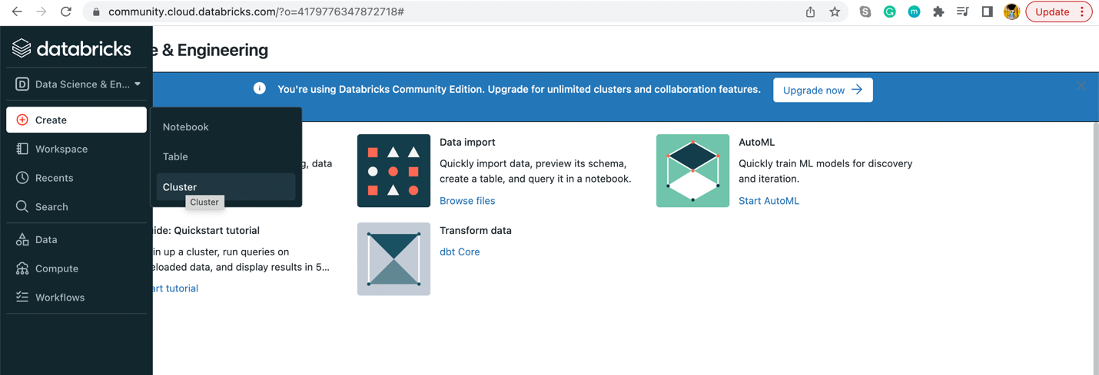

2. Enter the name of your cluster, select DataBricks run time version and click

create cluster

3. Click Event log and verify the cluster status

4. Create new Scala notebook

5. Create an instance of Hive Context:

6.Create a hive table person1 with first_name, last_name,and age as columns

7.Upload the sample.txt file. Click in the left pane and navigate to create table

or you can navigate to File upload in the Scala notebook screen to upload the

file into tables folder

Note: I did not find the sample.txt.file in the modules,As the file is fairly small, I created a Person1.Csv file with same table contents.

8. Load the data into person1 table

9. Select the person1 data using HiveQL

10. Create a new table from the output of select query

